Week 2
Data Cleaning &Validation Report
- Data Integration
  - Objective- The objective of the data integration phase was to combine the Opportunity and Learner datasets into a single analytical dataset. This integration enables the analysis of learner applications together with the corresponding opportunity details, providing a unified view for reporting, dashboard creation, and business analysis.

  - Understanding the relationship-
The project consists of two datasets:
- Opportunity Dataset: Contains information related to internships, jobs, workshops, scholarships, and other opportunities.
- Learner Dataset: Contains learner application records, including application status, payment information, completion status, rewards, and learner progress.
The business relationship between these datasets is One-to-Many, where a single opportunity can have multiple learner applications.

  - Join Key Investigation-
Initially, no direct common key was available between the two datasets. Therefore, multiple candidate fields were investigated to identify the correct relationship.
The following fields were examined:
- pk
- relation_id
- work_item_sk
- sk
- opportunity_id
- external_reference_url
Each candidate key was validated using SQL queries to determine whether it could establish a reliable relationship between the Opportunity and Learner datasets.

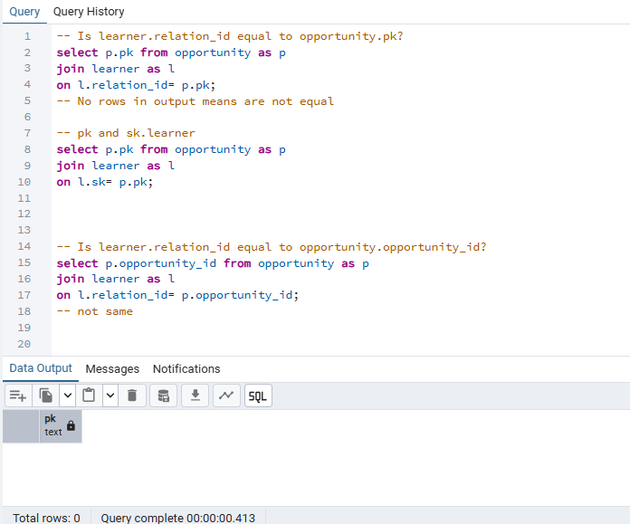
Fig 1.1 Checking rows for join

During the investigation, it was observed that the sk column in the Learner dataset and the opportunity_id column in the Opportunity dataset contained the same underlying identifier but with different entity prefixes.

Example:
Opportunity Dataset
Opportunity#000000000GBD0AX3Z6VYRG7R75
Learner Dataset
Learner#000000000GBD0AX3Z6VYRG7R75
Although the identifiers represented the same entity, the prefixes prevented a direct SQL JOIN.

  - Data Transformation-
To establish the relationship between both datasets, the entity prefix in the Learner dataset was standardized using PostgreSQL's REPLACE() function.
The transformation converted:
Learner#XXXXXXXXXXXX
into
Opportunity#XXXXXXXXXXXX
using the following logic:
REPLACE(sk,'Learner#','Opportunity#')
This transformation created a common identifier that could be matched with the opportunity_id column in the Opportunity dataset.

  - Data Integration Process-
An INNER JOIN was performed using the transformed identifier.
Join Condition
o.opportunity_id =
REPLACE(l.sk,'Learner#','Opportunity#')
The integration produced a consolidated dataset containing opportunity information together with learner application records.

  - Integration Validation-
After performing the integration, the results were validated using SQL.
Validation Metric | Result
Total Learner Records | 15,029
Successfully Matched Records | 14,799
Unmatched Records | 230
Match Percentage | 98.47%
The high match percentage confirms that the transformation and join logic successfully established the relationship between the two datasets.
The remaining unmatched records (1.53%) are considered potential data quality exceptions and may represent missing opportunity references, archived opportunities, or incomplete records.

  - Integrated Dataset-
The integrated dataset combines information from both source tables, allowing opportunity details and learner information to be analyzed together.

  - Key Observations-
- No direct foreign key was available between the datasets.
- Data profiling identified sk and opportunity_id as candidate keys with different entity prefixes.
- Prefix standardization using the REPLACE() function enabled successful integration.
- Approximately 98.47% of learner records were successfully integrated.
- Only 230 learner records remained unmatched, indicating a relatively high-quality integration.
- The integrated dataset provides a reliable foundation for further analytical processing.

- Data cleaning & Transformation-
2.1 Overview
After successfully integrating the Opportunity and Learner datasets into a single dataset, a comprehensive data cleaning process was carried out to improve the overall quality, consistency, and usability of the data. The objective of this phase was to identify and resolve structural issues, remove unnecessary attributes, standardize inconsistent values, transform data into appropriate formats, and prepare the dataset for exploratory analysis and dashboard development.
The cleaning process was performed using Python (Pandas) after the integrated dataset was extracted from PostgreSQL.

2.2 Initial Dataset Assessment
The integrated dataset was first profiled to understand its structure and identify data quality issues.
Metric | Value
Total Records | 14,799
Total Columns | 289
Duplicate Records | 0
Columns with Missing Values | 285
Constant Columns | 1 (opportunity_pk)
Observation
The dataset contained a large number of missing values, redundant attributes, export-generated columns, and inconsistent categorical values. These issues were addressed systematically during the cleaning process.

2.3 Removal of Export Artifacts
During data profiling, 213 columns beginning with Unnamed: were identified.
Investigation
These columns were generated due to issues during the CSV export process where long JSON strings overflowed into additional columns. The values contained fragmented metadata rather than meaningful business information.
Examples included:
- JSON fragments
- Tracking question metadata
- Partial configuration values
Since these columns did not represent valid business attributes, they were removed from the dataset.
Cleaning Action
- Identified all columns beginning with Unnamed:
- Verified that they contained fragmented export data
- Removed all export-generated columns
Outcome
The removal of export artifacts significantly reduced dataset complexity while preserving all meaningful business information.

2.4 Removal of Corrupted Metadata Columns
Several columns contained application configuration metadata rather than analytical information.
Examples included:
- tracking_questions
- appear_in_wishlist
Investigation
These attributes contained nested JSON objects describing dynamic application questions rather than learner or opportunity information.
Since these fields represented backend application configuration and did not contribute to business analysis, they were removed.

2.5 Standardization of Categorical Values
Several categorical attributes contained inconsistent naming conventions.
The following standardization rules were applied.
Column | Cleaning Action
Location | Standardized "wfm", "work from home", and "virtual" values
Team Name | Converted to lowercase, removed extra spaces, replaced dummy values
Marketing Source | Converted camelCase values into readable labels
Terms & Conditions | Standardized TRUE/true values
Example
Before
work from home
wfm
virtual
After
Work From Home
Virtual

2.6 Merging Duplicate Business Fields
Two consent-related attributes were found to represent the same business concept.
Original columns:
- i_agree_to_terms_and_conditions_of_global_shala
- i_have_read_and_agreed_to_the_terms_and_conditions
Cleaning Action
- Standardized values
- Created a single consolidated field
terms_conditions_accepted
The original columns were removed after validation.

2.7 Data Type Transformation
Several attributes required conversion into appropriate data types.

Date Columns
Unix timestamp values such as
1772613347423
were converted into datetime format.
Examples:
- opportunity_created_at
- opportunity_modified_at
- apply_date
- completion_date
- withdraw_date
Numeric Columns
Text-based numeric values such as fee and payment amounts were converted into numeric data types for future calculations.

2.8 Handling Missing Values
Missing values were analyzed using a business-driven approach rather than applying a single imputation method.
The remaining missing values were categorized into four groups.
Category 1 – Event-Based Attributes
These fields represent business events that occur only under specific conditions.
Examples:
- completion_date
- reward_awarded_date
- withdraw_date
- dropped_out_date
- accept_reject_date
- transaction_id
Action
No imputation was performed.
The missing values indicate that the corresponding business event never occurred.

Category 2 – Descriptive Text Fields
Examples:
- summary
- testimonial
- role_responsibility
- short_description
Action
Missing values were replaced with
Not Available
to improve dashboard readability.

Category 3 – Categorical Attributes
Examples:
- category
- location
- assigned_cohort
Action
Missing values were replaced with
Unknown
where appropriate.

Category 4 – Business Metadata
Examples:
- relation_id
- current_editor
- panellist
- team_name
- work_item_sk
Action
These columns were retained with missing values because they represent optional operational information and may support future business analysis.

2.9 Data Cleaning Decisions
Cleaning Activity | Action Taken
Duplicate Records | No duplicate rows found
Export Artifacts | Removed 213 Unnamed columns
Corrupted Metadata | Removed tracking_questions and appear_in_wishlist
Duplicate Business Fields | Merged Terms & Conditions columns
Date Conversion | Converted Unix timestamps into datetime
Numeric Conversion | Converted fee and payment-related columns
Category Standardization | Standardized location, marketing source, and team names
Missing Values | Business-rule-based treatment
Text Standardization | Removed extra spaces and standardized capitalization

2.10 Final Dataset Summary
Metric | Before Cleaning | After Cleaning
Rows | 14,799 | 14,799
Columns | 289 | 65
Duplicate Rows | 0 | 0
Export Artifact Columns | 213 | 0
Data Types | Mixed | Standardized
Categorical Values | Inconsistent | Standardized

6.11 Data Quality Improvement
The following improvements were achieved during data cleaning:
- Removed export-generated columns.
- Eliminated corrupted metadata fields.
- Standardized categorical attributes.
- Converted date and numeric fields into appropriate formats.
- Preserved business-relevant missing values.
- Improved overall consistency of textual data.
- Reduced dataset complexity while maintaining analytical value.
- Prepared the dataset for exploratory data analysis and dashboard development.

2.12 Conclusion
The integrated dataset was successfully cleaned and transformed using Python (Pandas). Structural issues caused by the CSV export process were resolved, redundant and non-analytical attributes were removed, inconsistent values were standardized, and data types were corrected. Missing values were handled using business rules to preserve the semantic meaning of event-based information. As a result, the dataset was reduced from 289 to 65 high-quality analytical attributes while maintaining all 14,799 records. The cleaned dataset is now suitable for exploratory data analysis, visualization, dashboard development, and business intelligence reporting.

- Data Validation & Quality Assessment
This is where you should show the evidence that your cleaning worked.
Include:
3.1 Final Dataset Summary
Metric | Before Cleaning | After Cleaning
Total Rows | 14,799 | 14,799
Total Columns | 289 | 65
Duplicate Rows | 0 | 0
Missing Value Columns | 285 | (Remaining business-valid columns only)
Export Artifact Columns | 213 | 0
Data Types | Mixed | Standardized

3.2 Missing Value Comparison
Show:
- Before cleaning
- After cleaning
Example:
Column | Before | After | Action
Unnamed Columns | 213 | 0 | Removed
tracking_questions | Present | Removed | Removed
appear_in_wishlist | Corrupted | Removed | Removed
Terms & Conditions | 2 Columns | 1 Column | Merged
completion_date | Missing | Missing | Retained (Business Valid)

3.3 Data Type Validation
Example:
Data Type | Before | After
Object | 289 | 46
Integer | 0 | 0
Float | 0 | 4
Datetime | 0 | 12

3.4 Duplicate Validation
Duplicate Rows Before : 0

Duplicate Rows After : 0

3.5 Final Missing Value Summary
Explain that the remaining missing values are intentional because they represent business events rather than data quality issues.
Example:
Column | Reason for Remaining Missing Values
completion_date | Opportunity not completed
withdraw_date | Learner did not withdraw
transaction_id | No payment transaction
reward_awarded_date | Reward not awarded
accept_reject_date | Application not processed

